**Historical Aspects of Mining**

Society uses many non-renewable Mineral Raw Materials. These materials include minerals containing metals, like Iron, and Gold, energy minerals like coal and lignite, ornamental stones like marbles and granites. The Figure shown below illustrates the life cycle of metallic Mineral Raw materials. Mining and related processes are presented on the top row, whereas on the right part of the figure, a circular pattern is formed. The circular use of mineral raw materials is important to achieve within the aim to increase the resources efficiency.

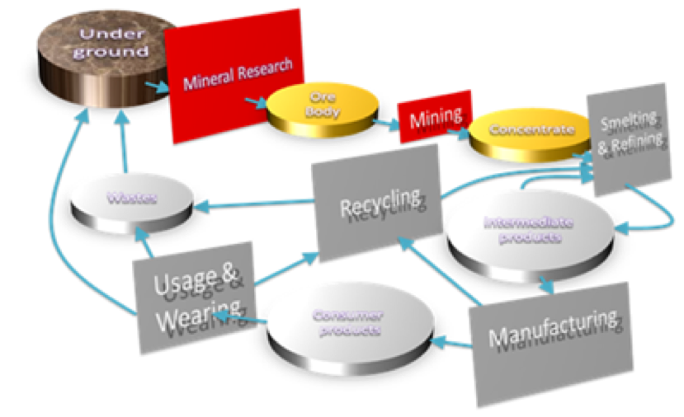

*Figure 1: The life cycle of Mineral raw materials*

But is the extraction and recycling of raw materials a new thing? In fact we have mined for metals and minerals for thousands of years to make products crucial for the development of humanity. The development of human societies through the Bronze Age and the Iron Age has been mostly defined by the products of mining that were determined by the technologies of the times. In the Figure below, miners in the adits of Ancient Lavrion, (5th century BC) where Pb and Silver were mined are seen.

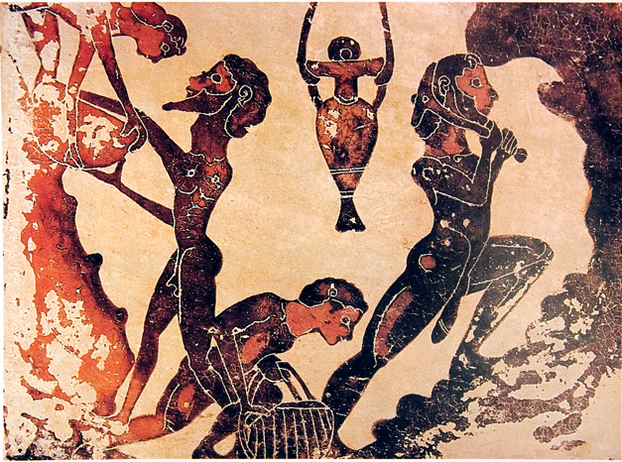

*Figure 2: Miners in the adits of Ancient Lavrion*

Regarding resources efficiency, it's noted that some sort of metals recycling has always been performed. Some of them due to their properties were inherently suited for circularity and have always been considered too valuable to be disposed with no further use. But this was not the case for all metals- even today the average recycle rate recorded is not as high as it should be. To document the above, the average recycle rate of a number of metals is given below.

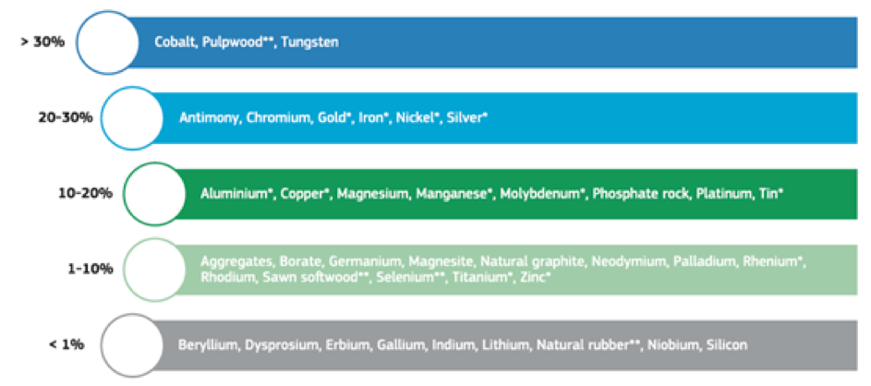

*Figure 3: End-of-life recycling input rates (EOL-RIR) for a selection of raw materials, JRC 2015*

Regarding land planning, mines are located where minerals are located! In countries like USA, Canada, Australia mines are often located in remote places, far away from urban developments. In other cases in many European countries, mines are sometimes close to places where many people live. Indeed, there are many cities and towns that started their histories as places of mining and communities are often attached to mines.

**Further reading**

EU Raw Materials Information System <http://rmis.jrc.ec.europa.eu/>

<https://ec.europa.eu/environment/topics/waste-and-recycling/mining-waste_en>

**Exploration and Extraction**

It is important to know that before the commencement of mining operations a lot of work has to be performed initially related with the exploration of mineral deposits and the definition of ore reserves. The very first step in mining is the search or exploration for mineral deposits. For hundreds of years, humankind has searched for ‘ore bodies’ to mine. And this search has led them far into remote areas, and essentially to every part of the globe.

Exploration includes a number of steps, from examining a geological map, i.e. geological exploration, to site investigations, grab sampling, non- destructive geophysical surveys, and of course exploration drilling. These exploration activities may last years and cost millions. At that stage it should be noted that exploration activities, also bear with it environmental impacts, e.g. opening new access roads in pristine environments, that need to be taken into account when viewing sustainability. In the following Figure an exploration Drill is shown.

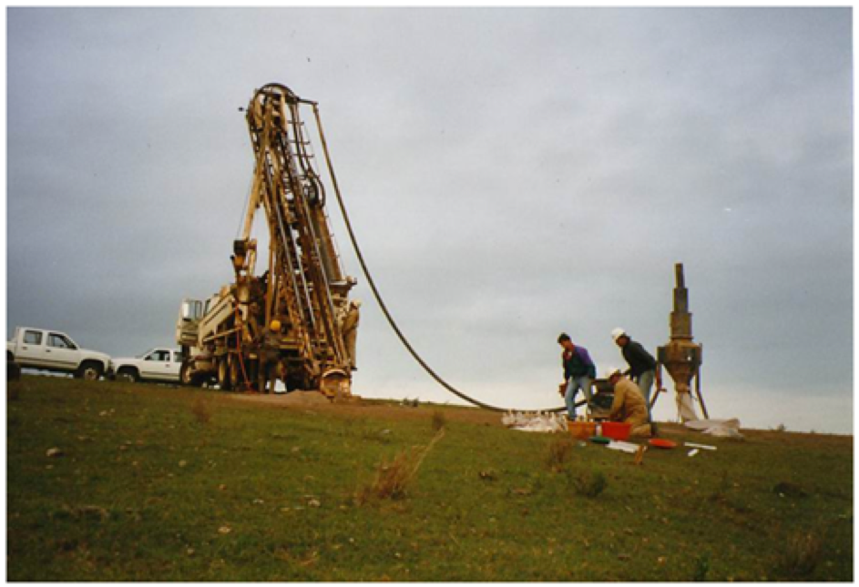

*Figure 1. Exploration drilling machine*

After mineral exploration and drilling, and based on the value of the contained minerals, a model of the sub-surface that looks a little like the one shown on the background is developed. In this model, each brick represents a unit area of the deposit. Warm colors represent the blocks to be mined because their value is higher than the cost to extract them. A design of a mine and a plan of how and when to extract the minerals can then be developed based on such a model. Nowadays, the mine plan should meet all the three objectives of sustainability, that is, economic viability, environmental protection and societal support.



*Figure 2. A model orebody*

Following the 3D definition of the mineable ore reserves, the mine design is implemented. Parameters that significantly impact the selection of the mining methods, include the form and the extend of the ore deposit, the geotechnical properties of the deposit and the host rocks, the presence of ground waters, the environmental sensitivity of the area, the proximity with urban settlements and areas of cultural heritage etc. Thus, a mine can be deep underground with only small entrances from the surface when the deposit extends in great depth, or it can be an open pit if the deposit is very close to or reaches the surface. Sometimes such mining pits are so big that they can be seen from space. In other cases when the mine extends under a community mining voids are filled with extractive wastes and cement in order to increase the stability of the underground workings and prevent land subsidence.

Such a large operation like mining, if not properly designed and managed may of course have many potential impacts, on ecological and hydrological systems and on the stability of the landforms. Therefore and as already stated the mine plan must also take into account for issues like the protection of water resources, geotechnical stability and so forth.

Once a mineral deposit has been located and ‘developed’, mining typically involves the extraction of significant volumes of valuable minerals and waste rock from mineral deposits. For example, in a large iron ore mine, annual production can total tens of millions of tons per year.

Most often, the valuable minerals will only comprise a small percentage of the rocks or ‘ores’ that we extract – thus, processes of crushing, milling and concentration are then required. This processing aims to separate the valuable minerals from the waste materials. Thus, after grinding and screening (in essence a sieving process), physical and physicochemical separation methods are applied based on differences in properties such as specific gravity, magnetism, color, etc. between the valuable minerals and the gangue materials. After processing, a concentrate where the valuable minerals are recovered is produced, as well as the tailings, where the waste materials are found.

Related to the fact that we often mine significant volumes of ore, and that only a small proportion of the material extracted may be the ‘product’ that is sent away from the mine, the mine clearly can create a large environmental footprint. If not properly planned and managed, a mine may create increased voids and large waste deposits.

<https://ec.europa.eu/environment/topics/waste-and-recycling/mining-waste_en>

**The Footprint of Mining**

The extractive wastes that we often create are mainly in the form of waste rock or ‘tailings’.

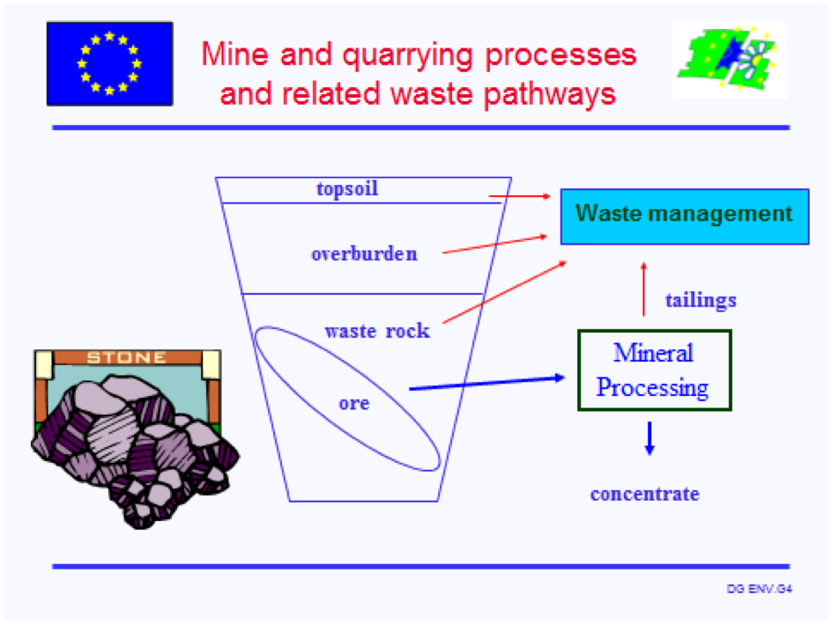

*Figure 1. Μine and Quarrying processes and related waste pathways, F. Papoulias, 2007*

As shown in the above figure, Waste rock is the overburden or the host rock material we extracted in order to access to the economic ore. Tailings, the other major type of extractive waste consists the rejects from the mineral processing activities. It is generally a fine sandy material produced when the original ‘ore’ was finely ground to extract the mineral of interest. These wastes are usually deposited in a pulp form close to the mine site in a tailing management facility. In many instances above wastes, either waste rocks or thickened tailings can also be used to fill the voids of the mined out areas. A good mine design often has the reuse of wastes as backfilling material as a key objective since this Best Practice can both result in reduced mine footprint and reduced environmental risks, see Figure 1.

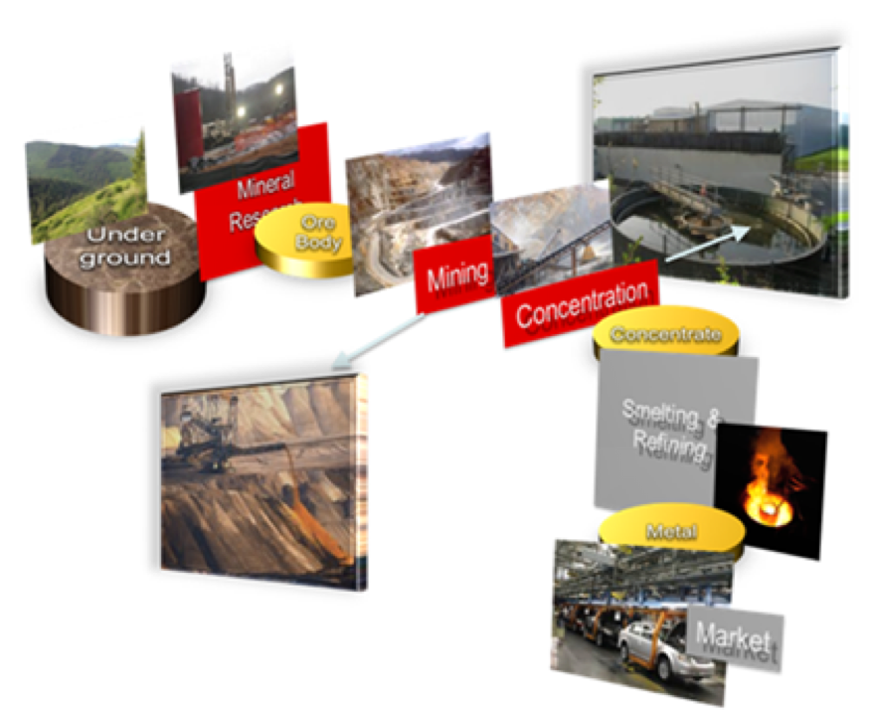

*Figure 2. Processes that take place on a mine site*

Interestingly, in many projects around the world, these old waste deposits have become mines! Due to the increase of, the metal prices and the development of innovative mineral processing techniques, wastes and tailings from older mines can be profitably reprocessed and recycled to recover the contained metals.

Finally, after mining and processing the Mineral Raw Materials, the small portion of valuable concentrate or metal is shipped or transported to places where it is smelted or further refined, or both. Smelting aims to treat the concentrate and recover the contained metal. Refining is used to further improve the quality of produced metals and remove any remaining impurities

In the whole life – cycle of a mine from exploration to closure, planning and design must take into account not only the economic viability of these operations, but also the consistent compliance with the sustainability principles. Measures are applied and careful management is required to protect ecosystems, neighbouring communities, and sites of cultural heritage, if any. Application of prevention measures, design of reclamation works and ongoing management is needed to make sure that the quality of the natural and manmade environment remains protected once the mining and processing operations have closed. Important parameters include, amongst others, soils and water. Quality and Quantity of Underground and surface waters need to be protected to cover drinking water needs of the neighbouring communities, and the quality of downstream habitats. The protection of soil and water quality close to the mine is a prerequisite to sustain agricultural activities during and after the mining operations. Post closure use of the mine site needs also to be considered.

In conclusion, mining is an activity related to the development of the mankind and therefore it should follow the needs of the society, not only regarding its secure supply of raw materials but also its commitment for environmental protection. So, environmental protection measures in order to minimise the footprint of mining, are necessarily incorporated in the whole mine life-cycle, from exploration to closure.

<https://ec.europa.eu/environment/topics/waste-and-recycling/mining-waste_en>

# Sustainable Mining - Part I

Sites of mining left without rehabilitation often pollute the environment, and can pose serious risks to both ecological systems and society. Yet, before the1960s or 1970s there was little consideration of the environmental and social consequences of mining. Before this time, we seldom restored natural systems around mine sites, or made efforts to look after the mining communities after the end of mining operations. Developed nations, as well as the developing and emerging economies, now face decades or even centuries of work with the clean-up of mines and mining debris. Because of such legacies, it is well known that mining practice must not follow the practices of the past where sites were often simply ‘abandoned’ after mineral extraction ceased. It is simply unsustainable.

Important to this discussion is that after the 1960s, and particularly from the 1970s onwards, there were considerable changes in expectations from society surrounding care for the environment. It became markedly less acceptable for industry to treat pollution and waste as externalities, and global civil society continues to demand stricter constraints on activities that cause environmental and social harm. The mining industry has been a significant target of such demands. Environmental NGOs such as the WWF and Greenpeace were important in mobilising public criticism of mining. In parallel, the rise of international treaties such as the UNESCO World Heritage convention of 1972, encouraged Governments to restrict access to areas of land of natural significance, or claimed by indigenous peoples.

Pressures for improvement were amplified globally throughout the 1990s with help from information technology – with the rise of the internet, awareness of mining operations in far off places could be brought to public attention, and local communities could be empowered with information, and resources. This put further pressure on actors such as governments, mining companies, institutional investors, and the World Bank to improve their mining-related activities – and also to demand improvement of the way mining operations were carried out. Such pressures increasingly encouraged mining companies to reduce pollution, to consider the state (and function) of land and ecosystems after the end of mineral extraction activities, and to take up CSR work with communities.

During these decades, the mining industry also became more globalised, and then formulated increasingly detailed codes of conduct. The industry also built forums for self-regulation of sustainability related performance. Great improvements in practice have been observed. The new types of practice that have been increasingly adopted in leading mining nations have shown that these problems and the financial and human costs associated with them are avoidable. That which is required is a process of intelligent planning prior to, and during mining – combined with strict but fair regulatory frameworks from Governments. Terms used to describe such have many names; these include ‘best environmental practice for mining’ – ‘integrated mine planning’ – or ‘sustainable mining practice’.

A growing number of countries have shown that achievement of such goals is feasible and that sound governance – from both private and public actors is key to success. Indeed, many experts believe that the key area for the mining industry to focus upon are sustainability challenges such as access to land, management of polluted mine drainage, the sharing of mining benefits and the rights of indigenous people. The manner in which industry, public authorities, NGOs and academics have progressed those challenges must be continued, expanded and improved. Further, there is evidence of a growing need for companies to go further than what legislation demands in order to gain (or maintain) stakeholder support, known as a ‘social licence to operate’.

This need to maintain social licence through improved performance in a combination of environmental, social and economic areas appears in different forms throughout the world but there are common themes. Governance of mining that reflects sustainability requires planning for the entire life cycle of a mine – and the environmental and social effects of the operation.

In its simplest form, this requires that a mine closure plan should be an integral part of a project life cycle and be formulated to ensure that:

• future public health and safety are not compromised;

• environmental and resources are not subject to physical and chemical deterioration;

• the after-use of the site is beneficial and sustainable in the long term;

• any adverse socio-economic impacts are minimized, and

• socio-economic benefits are maximized.

Sustainable mining also requires that the polluter pays principle is strictly applied by legislators, and that miners and governments find ways to ensure that financial resources are available before, during, and after mine operation to pay for the costs of closure. However, continual oversight of mining activities and pressure from NGOs and civil society is crucial to maintain pressure on both mining companies, and on Governments to ensure that the environment is protected. The danger of backsliding from commitments to responsible practice (from both Miners and Governments) is always a risk;  particularly at times of economic downturn is always present.

**For further reading see:**

Peck, P. C. (2005). Mining for Closure: Policies and Guidelines for Sustainable Mining Practice and Closure of Mines. Geneva: UNEP, UNDP, OSCE, NATO. Retrieved from <https://www.researchgate.net/publication/262259186_Mining_for_Closure_Policies_and_Guidelines_for_Sustainable_Mining_Practice_and_Closure_of_Mines>

Hojem, P. (2014). MAKING MINING SUSTAINABLE: OVERVIEW OF PRIVATE AND PUBLIC RESPONSES, LULEÅ UNIVERSITY OF TECHNOLOGY. <https://www.ltu.se/cms_fs/1.124549!/file/rapport%20making%20mining%20sustainable_low.pdf>

# Sustainable Mining - Part II - Progress Towards Sustainable Mining Practice

# Progress towards sustainable mining practice

Essentially all mining operations must close sooner or later. Mineral deposits are finite, and often run out. In other instances, minerals may remain, but it becomes too expensive to extract them for reasons such as the mine becoming being too deep, or the concentrations too low. Earlier in this lesson we noted that unsustainable mining has left many mine sites legacies for future generations to pay for. Inadequate planning for the end of mining can have a range of significant negative socio-economic effects.

If mine legacies are left behind, it is usually governments that at some stage have had to pay for responsible mine closure and rehabilitation. Historically, if anyone helps the communities, it is also the government that must cover the social costs related to mining town communities that have been disrupted by ‘the end of mining’. Having to spend government money on such things, in turn reduces funds available for other social goods such as education, healthcare and infrastructure elsewhere in society.

Just looking at three leading mining nations – Australia, Canada and the US demonstrates that the problem is very large. In Australia, there could be 60 000 abandoned mines to be rehabilitated; while Canada has an inventory of more than 10 000 of what they call ‘abandoned or orphaned mine sites’. The Federal Bureau of Lands in the US reports that they may have as many as 500 000 abandoned sites. It is estimated that the clean-up costs will run into many 10s of billions of (US) dollars for each of these countries.

However, in general, these figures are just the clean-up costs – focused on preventing ongoing damage to the environment and public health – but when a mine closes, it can often result in other serious socioeconomic impacts. Indeed, whole economies can be affected by a downturn in mining, however, the socio-economic effects of poor management of mineral extraction industries are often most visible at the mine community level.

All around the world there are examples of communities in crisis because the ‘economic engine’ that supported them has declined or closed. To understand why some towns are so closely bound to mining operations one needs to look back to the process of mining itself. Mineral resources are found where geological processes placed them – and in many instances, this is far from important trade routes, or rich agricultural land where population centers have traditionally formed. New mineral resources are also commonly found in less developed countries – or in sparsely populated regions.

Consequently, many mine towns are located in areas that communities may not have traditionally formed. While a mining operation can support vibrant the building of busy townships and communities – there may be little to support that community if the mine closes. This is a challenge shared by both developed and developing nations. It is also important to note that the socio-economic relationship of a mining operation to a country, region, or town is something that grows over time. As such mining communities often exist for long periods of times the mining operations, and how they impact communities, have inter-generational consequences.

While a mine project life plan needs to be followed to protect environmental resources, and ensure public health and safety, both now and into the future, forward thinking is also required on the social side. Plans need to be made, and investments may need to made, during the mine life, in order ensure that social and economic conditions can support communities post-mining.

Because mines are often the first major economic activities in a remote area, or a developing country, they can also be very important for national economic development processes. Such parameters make it very important that governments ensure that the wealth generated by mining is managed well and invested for the future of the country, as well as the host communities for mines. Governments also need to ensure that revenues are fairly distributed among the society.

A sustainable approach to mining thus requires the explicit inclusion of social and economic aspects in the planning for mining operations – in addition to protection of natural resources. When mining is finished, sustainable mining demands that structures are in place to ensure that adverse socio-economic impacts are minimised; socio-economic benefits are maximised, and that after-use condition of the site is beneficial and sustainable in the long term.

**Further readings**

Peck, P. C. (2005). Mining for Closure: Policies and Guidelines for Sustainable Mining Practice and Closure of Mines. Geneva: UNEP, UNDP, OSCE, NATO. Retrieved from [here](https://www.researchgate.net/publication/262259186_Mining_for_Closure_Policies_and_Guidelines_for_Sustainable_Mining_Practice_and_Closure_of_Mines).

# Environmental Constraints

A baseline requirement for environmental sustainability is that the management policies, field practices and technologies applied in mining reduce environmental harm to within ecological limits. At the same time, land must be preserved as a repository for biodiversity and for natural ecological services. With such conditions in mind, there are a number of fundamental physical and chemical issues that must be considered in order to achieve environmentally sustainable mining.

1. Rocks and ores are not at ‘equilibrium’ when brought to the surface and can become chemically and physically unstable when exposed to surface conditions, potentially releasing eco-toxic substances. Unless planned for, prevented, or contained, such processes can cause damage that lasts for very long periods of time.
2. Mine development often occurs on undisturbed land. When a mine is opened in some areas, access to nearby sensitive or undisturbed areas by other groups - for example loggers or farmers - may not be compatible with overall sustainable land use. For such reasons, access to a mining area may be restricted, and authorities may opt to not develop a town or public access roads. Such strategies can help ensure that valuable natural systems are protected for future generations.
3. Mineral ore bodies are finite and all mines reach the end of their viable life at some time. Therefore, sustainable mining requires planning from the very beginning that guides both the mining activities and the closure of the mine site. A mine and all its wastes must be constantly managed, and then rehabilitated and prepared for after-mine life. The final landforms, hydrology and management strategies for the mine areas must ensure that environmental resources are not subject to physical and chemical deterioration in the long term.

**Managing a Mine-site From Before Mining Until After Mining**

ITEM 6 READING FOR PART III.

Management policies, practices and technologies that seek to achieve sustainable forms of minerals extraction must achieve a number of basic conditions. Here we work from the premise that they must reduce the environmental harm to within ecological limits – before, during AND after mining. The framework for how the environment is to be managed needs to be set before extraction starts; it needs to be followed and updated during the operational life; its rehabilitation requirements must be completed at closure, and then its after-care conditions must be met.

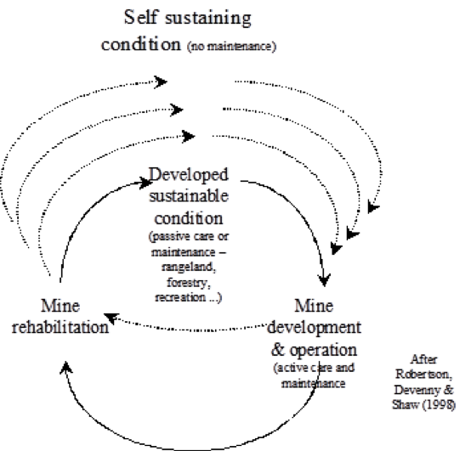

*Figure 1. Transitions to self-sustaining mine sites [source: “Mining for Closure” (Peck, 2005)] The figure conceptualises the idea that a active care and maintenance is required during mine development and operation, and that a considerable period of passive care or maintenance may be required before a self-sustaining condition is achieved.*

This ‘life cycle thinking’ for the pursuit of environmental sustainability has been developed in recognition of the particular challenges that have been posed by extraction of minerals through our history. While many issues exist, we choose to focus upon three.

A first challenge in this regard is that the processes of excavating materials from the sub-surface often exposes materials that are hazardous, or can become hazardous in their new environment. When things such as mineral ores, processing wastes, waste rocks, or even the walls of a mine are exposed to new physical, chemical and biological systems (e.g. such as the surface conditions where we can live) they can start to break down. A key example of a problem of this sort, is the production of acid and metalliferous drainage (AMD). This often takes the form of an outflow of acidic water from mines, or mine waste stockpiles – with the source of acid being rock matrices that contain sulphur. Many acid rock discharges also contain elevated levels of toxic, or potentially toxic, metals dissolved in the low pH waters.

If we are to ensure that environmental and resources are not subject to physical and chemical deterioration, that the public health and safety are not compromised, and that the after-use of the site is beneficial and sustainable in the long term, then such problems need to be managed from the very start of a mining operation. Of course, they must be managed during the operation and during closure. If a site is to be relinquished, then there should be natural systems that have them under (very) long-term control, and within ecological limits.

A second challenge is related to situations when mining-related activities are conducted in sensitive or undisturbed regions – where the establishment of mining opens access to the area. Roads, ports, or other forms of access, can make it easier for other destructive human activities to become established. Of particular relevance in this regard are threats to valuable natural systems, and traditional land-users. For such mining activities to be aligned with sustainability, specific strategies may be required to ensure that activities such as road building, farming, logging, artisanal mining, hunting and general recreation can be controlled, or prevented. If human settlements are a threat to natural systems, this can require that the establishment of a permanent settlement is avoided – for instance by having a mine ‘camp’ where workers live in a controlled area – and are transported in to a remote mine site from far away. Overall, it is important that mineral activities do not create situations where activities incompatible with sustainable land-use arise, or are made easier.

The third challenging issue for the environmental parameters of sustainable mining is the very lengthy time perspective that must be taken. If a mine site is to be relinquished (this means that at some time after the ending of mining or minerals processing activities, the mining company ‘hands back’ responsibility of the site to the state, or traditional owners), then it should have achieved a stable state where it can also be a repository for biodiversity and for natural ecological services in the long term. This should be perceived in terms of centuries rather than decades. In general, this long-term thinking requires acceptance that a former mining site may need quite a long period of management in the years between the closure of minerals-related activities, and actual relinquishment. This does not come for free – thus this clearly requires that in addition to the framework for environmental management mentioned earlier, there must be funds to support such work, or active land users that have a vested interest in ensuring that the site is cared for.

As part of dealing with the long time frames described here, ensuring that final landforms, hydrology and management strategies for the mine areas can protect environmental resources, must also involve stakeholders in some way. Among other things, this requires that planning processes for closure and relinquishment need to incorporate the concerns/participation of other stakeholders in the reclamation objectives, and legal considerations for ownership, in the past, now and into the future.

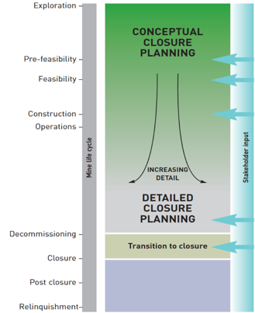

*Figure 2. Diagram from ICMM.’s Integrated Mine Planning Guideline.*

**From Ore to Metal**

Extractive metallurgy is the art of extracting and refining metals from their ores. The industrial processing route for the production of a metal, from its ore or concentrate to a refined metal, consists of a combination or sequence of operations performed in reactors (illustrated conveniently by means of a flowsheet). Metallurgical processes, occurring in the operations of extraction and refining of metals and alloys, involve homogeneous or heterogeneous chemical reactions.

Depending on the raw material and the target metal to be extracted, different technologies and processing routes can be applied or developed. Metallurgical routes of copper, silver, and gold are the best prehistoric manifestation of the human’s mastery of natural resources. Extracting copper from its ore dates back to the middle of the fifth millennium before our age and extracting iron from its ore dates from the beginning of the second millennium before our age.

The production (winning) of metals and alloys today is still one of the basic industries of the transformation of matter. Metals and alloys still are essential resources for metallic, mechanic, electromagnetic, electric and electronic industries.

The two main branches of extractive metallurgy are:

* pyrometallurgy: involving operations at elevated temperatures in the range of 500-2000°C, and
* hydrometallurgy: involving operations using liquid solutions from ambient temperature up to 250°C under pressure.

A unit operation is a single extraction process performed, such as roasting of a sulfide ore or the reduction of an oxide or a transfer process (removal of a component from a phase) such as acid dissolution and solvent extraction. In some operations, such as in blast furnaces, several processes occur in sequence from iron ore to hot metal (smelting) in the same reactor. All operations are carried out in different conditions: discontinuous (batch, closed), continuous (open) and semi-continuous (semi-batch).

**How is Aluminium Made?**

Aluminium compounds occur in all types of clay, but the primary ore for producing pure aluminium is bauxite. Bauxite consists of 45-60 % aluminium oxide, along with various impurities such as sand, iron, and other metals. Bauxite deposits consist of relatively soft dirt that is easily dug from open-pit mines. Australia produces more than one-third of the world's supply of bauxite. It takes about 2 kg of bauxite to produce 0.5 kg of aluminium metal.

Aluminium metal is manufactured in two distinct phases:

1. *The Bayer process* of refining the bauxite ore to obtain aluminium oxide, and
2. *The Hall-Heroult process* of smelting the aluminium oxide to produce pure aluminium.

*Bayer process*: Caustic soda (sodium hydroxide) is used to dissolve the aluminium compounds found in the bauxite under elevated temperature and pressure, separating them from the impurities. Depending on the composition of the bauxite ore, relatively small amounts of other chemicals may be used in the extraction. The final product from the Bayer process is called alumina (aluminium oxide), whereas the resulting solid waste for disposal is Bauxite residue.

*Hall-Heroult process*: Alumina is then transferred to electrolytic cells. Cryolite, a chemical compound composed of sodium, aluminium, and fluorine, is used as the electrolyte (current-conducting medium) in the smelting operation. The other major ingredient used in the smelting operation is carbon. The whole process is called molten salt electrolysis where carbon electrodes transmit the electric current through the electrolyte. During the smelting operation, carbon is slowly consumed as it combines with oxygen to form carbon dioxide. In fact, about 1 kg of carbon from the cathodes is consumed for every 1 ton of aluminium produced.

Because aluminium smelting involves passing an electric current through a molten electrolyte, it requires large amounts of electrical energy. On average, production of 1 kg of aluminium requires 15 kilowatt-hours (kWh) of electric energy while the cost of electricity represents one-third of the cost of smelting aluminium.

# Global Value Chains

Understanding where materials come from involves understanding the linkages between extraction and mining through to the end-of-use of the materials and products. While supply chain and material flow analysis can answer what materials flow where, global value chains analysis seeks to answer why and how materials flow.

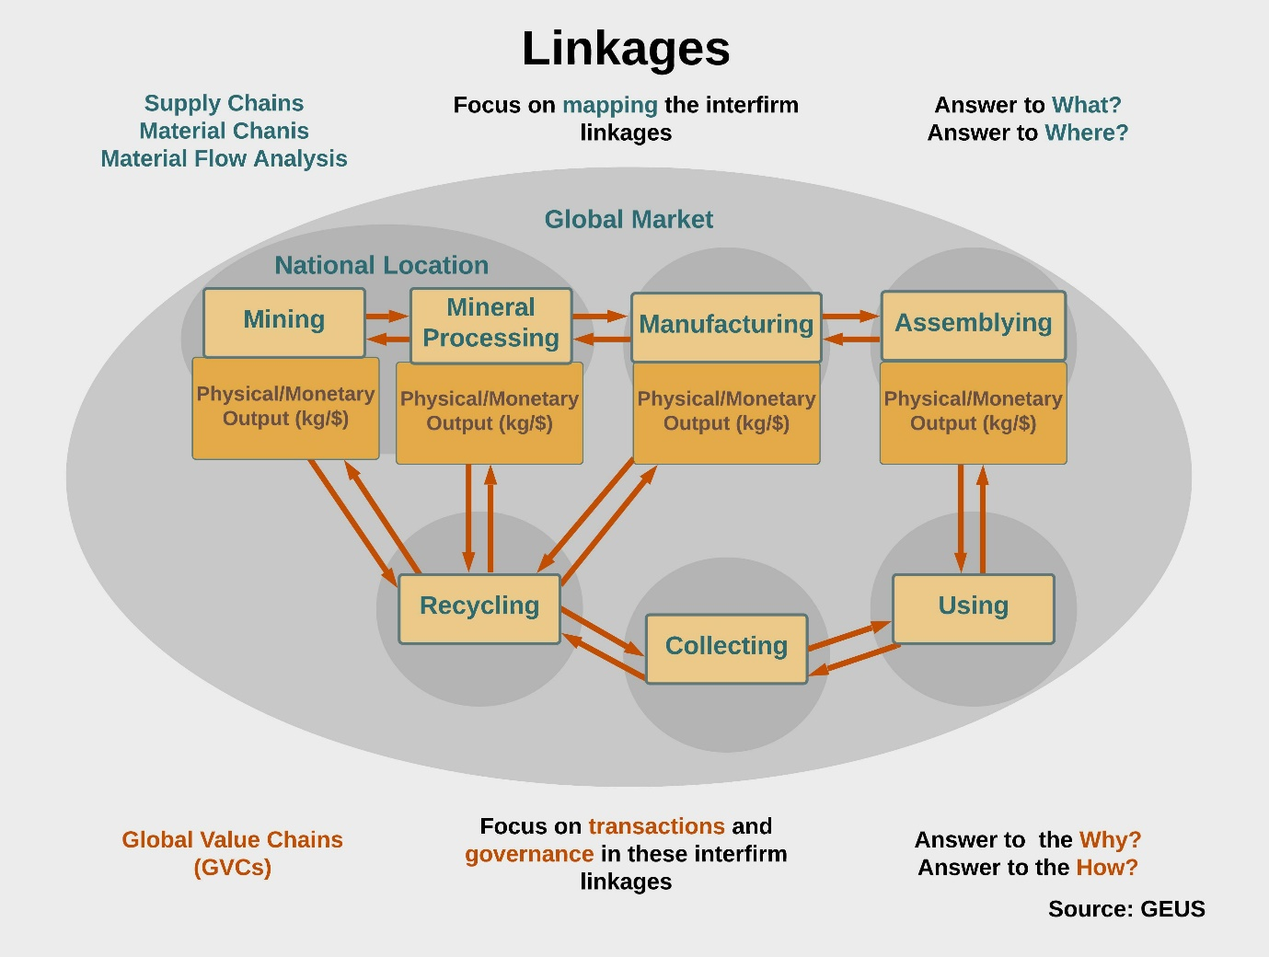

Figure 1. Linkages in global values chains. Source: GEUS

Many supranational institutions, such the United Nations Industrial Development Organization and the World Bank, draw on the global value chain (GVC) methodology and conceptual framework for their analyses of globalization and economic development of nations.

### Further Reading

World Bank (2017). Global Value Chain Development Report: Measuring and Analyzing the Impact of GVCs on Economic Development. [https://www.wto.org/english/res_e/booksp_e/g](https://www.wto.org/english/res_e/booksp_e/gvcs_report_2017.pdf)

# Research on Value and Governance (Extension)

The lesson on ***Value and governance*** provided very basic content on the subject as an outline rather than a comprehensive coverage of the subject. To learn more about how research on the "Why and the How" of material flows can be conducted, please continue reading here.

Research on the "Why and the How" of material flows occurs by examining valuation mechanisms, which can arguably best be achieved by the type of unit of analysis, whether it's a volume unit (kg/t), a monetary unit (USD/EUR) or, the transaction, in other words, the coordination and control mechanisms of the exchange.

### ****Analytical dimensions of the GVC framework****

Global Value Chain analysis was originally centred on **four analytical dimensions**: (1) an input-output structure and (2) a territoriality, the geographical dimension of material flows – both of which are mapped and can be desktop-studies; (3) governance structures are at the heart of GVC analysis, and, finally, (4) the regulatory framework of particular jurisdictions. In their recent, second edition ’GVC analysis – a primer’, Gereffi and Fernandez-Stark (2016, p. 7) extend these four dimensions to **six dimensions**:

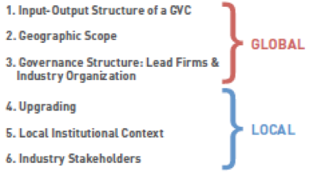

Figure 1: Six analytical dimensions.

### ****The analytical dimension of governance****

The governance dimension and GVC governance types are defined by means of transaction cost theory, reaching as long back as John R. Commons and Oliver Williamson in the 1930s. Commons described transactions as negotiations between the parties, rather than as exchanges of commodities.

In GVC analysis, transactions are examined with **three variables**, the ‘3 C’s’ of complexity, codifiability and capability that describe any given transaction. The **complexity** of a transaction describes how easy or difficult it is to make a successful exchange based on the information that requires exchanging between the buyer and the supplier. The **codifiability** of the transaction refers to the extent to which the exchange is/can be facilitated by existing standards, thus, harmonized information on a particular product (or material type). The **capability** of the supplier describes the extent to which the supplier can meet buyers needs/specifications without further instruction by the buyer.

These variables are then connected with a **low or high value**, from which **five governance forms** result that are depicted in the figure: market and hierarchy at the extreme ends, and three network forms in the middle, namely modular, relational and captive. These network forms describe transactions between buyers and suppliers that are in principal more equal.

Importantly, the **width of the arrows** in this illustration describes whether a link between a buyer and a supplier represents a transaction based on price (as in market governance) or includes also the exchange of additional information and control or coordination between buyer and supplier (as in the three network governance forms).

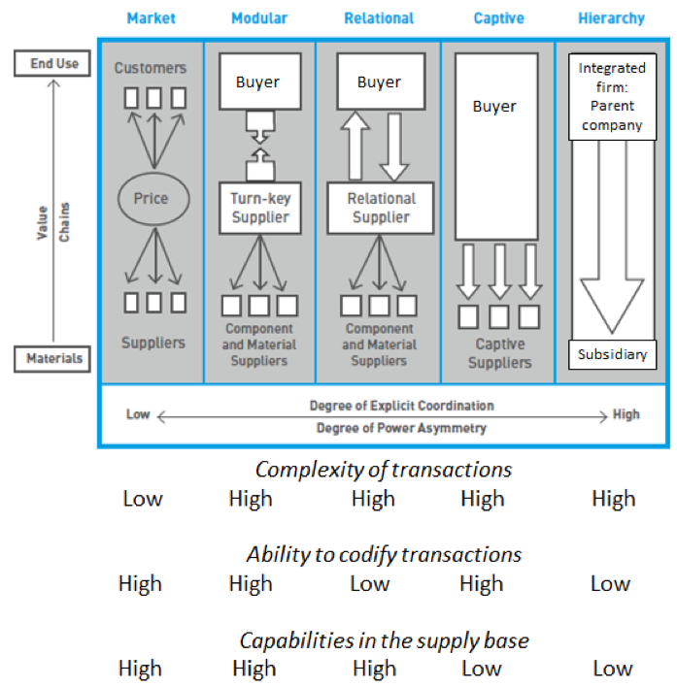

Figure 2. Governance types. Source: adapted from Gereffi et al., 2005.

Note: The Table 1 below the simplified illustration of governance types shows the three variables which are defining the transactions between the buyer and supplier and their allocated low and high values that determine the governance type.

In conclusion, in contrast to many other economic analyses that centre on price and volumes of material exchanges only, GVC analysis enables a more comprehensive understanding of market mechanisms: It depicts that transactions are not solely defined by price and material flows, but by the exchange of information, and, among other, the capabilities of the buyer and the supplier.

For further information on GVCs, including publications please follow this link to the [Global Value Chains Initiative](https://globalvaluechains.org/) at Duke University. A key source is the 2nd edition of “ "Global Value Chain Analysis: A Primer" by Gary Gereffi and Karina Fernandez-Stark which was released by the Center on Globalization, Governance & Competitiveness at [Duke University](http://www.cggc.duke.edu/) in July 2016. This second edition refines earlier GVC concepts and approaches, and introduces several new illustrations drawing from recent Duke CGGC research involving GVC analysis to inform industrial policy and the inclusion of small and medium-scale enterprises (SMEs) in GVCs.

A relatively new application of GVC analysis is in the field of workforce development, such as by the International Labour Organization (ILO, 2016). There the focus is on the skill dimension, i.e. from the perspective of the skill level in various job categories (see Gereffi and Fernandez, 2016, p. 22).

### ****Use of GVC analysis by supranational institutions****

The explanatory power for economic developments of a GVC analysis is uncontested, as demonstrated by its use as methodological framework in studies of supranational institutions such as of the United Nations Conference on Trade and Development, the World Trade Organisation, or the ILO. Furthermore, it has great potential for further development, specifically with a view to expanding the rigidity of its empirical findings from the local-national-regional scale to the global scale.

This reading summarised the analytical dimension of governance based on the research at the Duke Center on Globalization, Governance & Competitiveness (Duke CGGC) . You can find more extensive explanations about global value chain analysis in the full textbook: <https://gvcc.duke.edu/wp-content/uploads/Duke_CGGC_Global_Value_Chain_GVC_Analysis_Primer_2nd_Ed_2016.pdf>

# Criticality

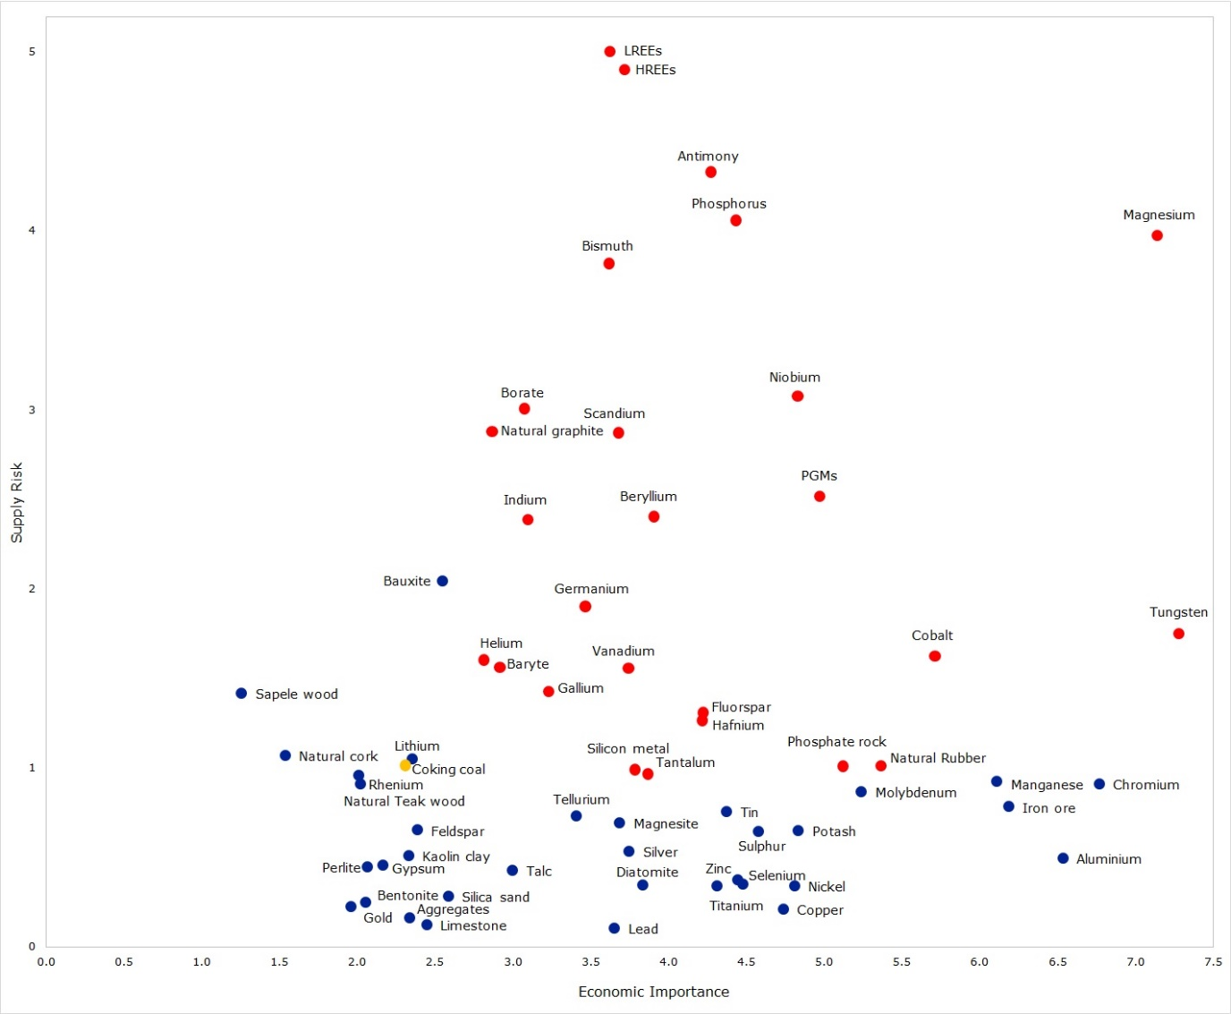

Figure 1. EU critical materials 2017 . Source: European Commission's Communication "On the 2017 list of Critical Raw Materials for the EU", COM(2017)490).

The lesson on criticality provided very basic content on the subject as an outline rather than a comprehensive coverage of the subject. This reading also provides a specific case example of criticality. The historical case of cobalt illustrates the complex and interwoven economic and geopolitical dynamics that come to play in the supply-demand balance of minerals, and how criticality can arise. In addition, the case lays out some arguments for the importance of conducting criticality assessments – despite the presence of various criticisms on the type of methodology that is to be applied in these assessments.

## The 1970s cobalt crisis

Cobalt has been known for volatile prices, especially in the period from 1966 to 1976 and from 1980 to 2002, where price changes from year-to-year price were about 40 %. Between 1977 and 1979, however, prices increased by 380 %, which led to the so called ’cobalt crisis’. A rebellion in Zaire, nowadays Congo, was the origin of the crisis.

Cobalt comes to use in a wide range of products particularly in the form of alloys, i.e. mixtures with other metals, such as in the manufacture of engines, magnets or turbines. In the early 1970s, Zaire and Zambia accounted for close to 70 % of world production, and Zaire was known to host 40 % of world land-based cobalt reserves. A single supplier, African Metal Corps (AMC), supplied all Zairian cobalt to the US, the world’s main cobalt consumer without own domestic production.

In the aftermath of World War II, the U.S. began to stockpile cobalt as the country’s awareness was raised about its strategic importance, yet in 1973, this stockpile was reduced. With a civil war in Angola, the railway that was used to export cobalt and transited Angola, was closed in 1975 which led to longer lead-times yet hardly noticed by downstream buyers due to the availability of cobalt from the sales of the US stockpile. Unrest in the African region led to reduced shipments by AMC, which were countered by US restocking and a new stockpile goal, accompanied by increases in cobalt demand for aircraft engines and drilling in the period from 1975 to 1976. Yet cobalt prices did not augment significantly from close to USD 9 000 to close to USD 12 000/ton.

In 1978, the electrical power to Congolese mines was stopped by insurgent Angolans for several days, and despite slow restoring of operations, cobalt production of 1978 exceeded the average yearly production between 1975 and 1977. Yet, with global cobalt demand on the rise and concerns for supply shortages in the rest of the world, speculation started. In early 1979, the price of cobalt reached USD 55 000/ton, even up to USD 99 000/ton at traders and remained high until 1982 (see Figure).

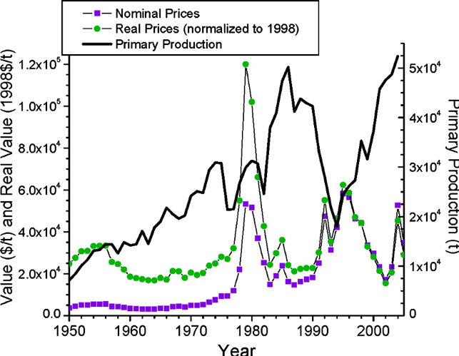

Figure 2. Cobalt average yearly prices and primary production 1950−2000 (8). Source: USGS Minerals information, 1932−2006, Mineral Yearbook and Mineral Commodity Summary found online at <http://minerals.usgs.gov/minerals/> In Alonso, E., Gregory, J., Field, F., Kirchain, R. 2007.

Short-term and long-term responses to the price peak were implemented. The former included upstream efforts on shortening the increased lead times by relying on air transport. Longer-term efforts included the stabilization and expansion of existing mining operations in Zaire. Zambia increased its production capacity, alongside Australia, which reduced the importance of Zaire's mining of cobalt. With these changes, Zaire only accounted for 31% of the world’s mined cobalt by 2004.

Firms involved in manufacturing cobalt-based components and products reevaluted their cobalt use. The magnet manufacturers as largest end-users of cobalt responded rapidly with decreasing the cobalt content in some of their alloys, yet not in superalloys where limited substitutes exist and demand increased for jet engines. The development of a recycling process for scrap superalloy brought about significant change for cobalt use as the process resulted in a doubling of cobalt recovery after 1978. Nonetheless, in light of increasing cobalt demand, and price rises, materials substitution and development of new technology was fostered. The following figure illustrates how the Samarium-Cobalt (SmCo) magnet technology development peaked in the early 1980s when the development of the Neodymium-iron-boron (NdFeB) magnet technology was invented and commercialized.

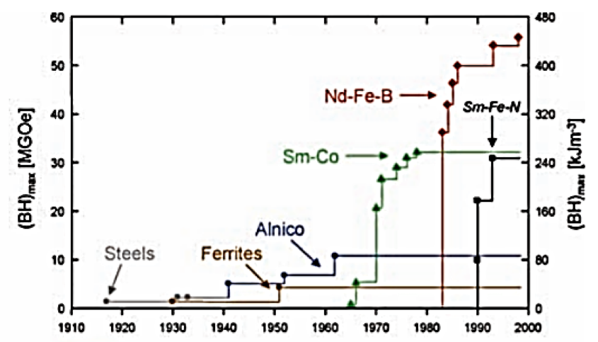

Figure 3. The development of permanent magnets. Source: Gutfleisch et al., 2011.

As illustrated on this case, the crisis was exacerbated by several factors, among other, the near-monopoly production of cobalt by Zaire and the limited substitution options for cobalt in the high-end uses of cobalt (superalloys). Responses by firms to mineral criticality are characterized by a complexity that originates in these factors. This is where the importance of criticality assessments finds their justification: To provide private- and public sector stakeholders with insights into supply security and economic importance so they can adapt their strategies by assessing the individual firm’s exposure to the criticality and to take anticipative action, if so decided.

### Further reading:

EU Commission. Critical Raw Materials. <http://ec.europa.eu/growth/sectors/raw-materials/specific-interest/critical_en>

Alonso, E., Gregory, J., Field, F., Kirchain, R. 2007. Material Availability and the Supply Chain: Risks, Effects, and Responses. Environ. Sci. Technol. 41, 6649-6656. DOI: 10.1021/es070159c

REmove

**How to Find Podcast Interviews**

When there is mention of an interview (as you will encounter shortly), the instructor is referring to a podcast in audio format. These additional podcasts can be found directly under the video in "Download". All of the podcasts and additonal resources in this course can be found using this section. If you are using a mobile device, the podcasts can be found under the lecture video in "Attachments". Both locations of podcasts are pictured below:

**EXAMPLE Screenshots of where to find podcast under lecture video using a computer:**

**(This is not a video nor does it have transcripts. These are example photos.)**



**Podcast under lecture video using a mobile device:**

